**Index**

1. Acknowledgement 2
2. *****Problem Definition & Existing system and need for the new system 3
3. Feasibility study 4
4. Requirement analysis 5
5. E-R Diagrams 6
6. Normalized Database Design & Data Dictionary 7
7. Use Case Diagram 8
8. Component Diagram 9
9. Deployment Diagram 9
10. Sequence Diagram 11
11. Class Diagram 12
12. 12
13. State Chart Diagram 12
14. Input & Output Screen’s 13

# Acknowledgement

I would like to express my special thanks of gratitude to my collage mam who helped me a lot in this project on the topic Pollution Complaint application.

I have taken efforts on this project from past three months. And finally it is working which I want. The project Pollution Complaint contains, a lot of modules which I developed from past three months. I developed and researched each and every module of this project. In this project I had seen the power of Java i.e. What Java can do?

I developed the on-board and off-board both the sides’ scripts. On-board side I used python scripting and off-board side I used JSP scripting. In this project, I developed modules like How to send mails?, How to represent temperature graphically? How to store passwords in database using SHA-1 algorithm? And so on. I had researched these modules from sources like Java and Java-Script standard books, from internet and past programming that I have developed some small programs. In this project, I learned so many things of Java and Java-Script. First time I developed a web application which can be run in real-time.

There are lots of problems and errors I had face during the completion of this project, like tomcat configurations to run JSP scripts, MySQL authentication and connections problems, Raspberry-PI’s connection problems, and so on.

I learned all the things like configurations of servers, MySQL authentication and so on. I searched these things on the internet. Internet is helped me a lot, to solve such errors and problems. And finally all of the efforts and researched was done with the completions of this project. I had tried to do the Pollution Complaint application coding professionally at the best of my knowledge and I had enjoyed the coding of this project.

# *****Problem Definition & Existing system and need for the new system

A problem definition is a brief overview of the issues or problems existing in the concerned area selected for the research. It is an explanation of the issues prevalent in a particular sector which drives the researcher to take interest in that sector for in-depth study and analysis, so as to understand and solve them.

I have searched the process to get activate connection, but there is no system for this process. This process is very complicated process and paper work based process. So we need solution to this manual process. There is no such manual defined system. The manual system may work on a person to person communication. These systems can be hectic and time consuming process.

**Need for the new system**

I want to develop a system which is useful for all the processes involve in activation of the E-airtel prepaid connection. By using this system we create party which has all the information about customer. This system generates unique account no. for each customer .Then we give different schemes to the user as his requirements & system generates book order no. & book order id. Which is then use for the activation of that connection. The purpose of this project is to learn the new technologies like JSP, Java-Script and so on.

# Feasibility study

A feasibility study is used to determine the viability of an idea, such as ensuring a project is legally and technically feasible as well as economically justifiable. It tells us whether a project is worth the investment—in some cases, a project may not be doable. There can be many reasons for this, including requiring too many resources, which not only prevents those resources from performing other tasks but also may cost more than an organization would earn back by taking on a project that isn’t profitable.

**Technical Feasibility**

This assessment focuses on the technical resources available for this project developer. It helps organizations determine whether the technical resources meet capacity and whether the technical team is capable of converting the ideas into working systems.

Our product is technically feasible because I develop this product as a web application there are finite number of software’s and hardware’s are required.

**Economic Feasibility**

This assessment typically involves a cost/ benefits analysis of the project, helping organizations determine the viability, cost, and benefits associated with a project before financial resources are allocated.

Our product is not a big budget but the costs of the hardware requirements are in thousands, that’s why our product is economically feasible.

**Operational Feasibility**

Operationally feasibility is a study to find out whether developed and implemented system will be useful or not? It is for finding out whether the developed system would comply with the users or will user’s resists using this system?

We make the product user friendly and accessible from any device and there is no need to give the much training to the user. Hence our Pollution Complaint application is operationally feasible.

# Requirement analysis

Software requirement is a functional or non-functional need to be implemented in the system. Functional means providing particular service to the user. Software requirement can also be a non-functional, it can be a performance requirement.

1. **Business requirements**

Business requirements are the high level requirements that are taken from the business case from the projects. As the purpose of this project is not from the perspective of business, it is only used for the collage requirement. Hence there are no business requirements from the project. This product is not for sell, it is only useful for collage academic purposes.

1. **Design requirements**

These requirements are more detailed than business requirements. It determines the overall design required to implement the business requirement. For this project, our design requirements are GUI development like, implementation of *add police station by admin, register complaint pages and so on.*

1. **Software’s & Hardware’s requirement (Project setup requirements)**
2. ***Software requirements:***
3. *Xampp Server* – To run JSP scripts.
4. *Notepad++* - To write codes and scripts.
5. *Browser* – Any browser on which application will run.
6. *JDK (1.8)* – Java Development Kit
7. *Platform* – Windows

# E-R Diagrams

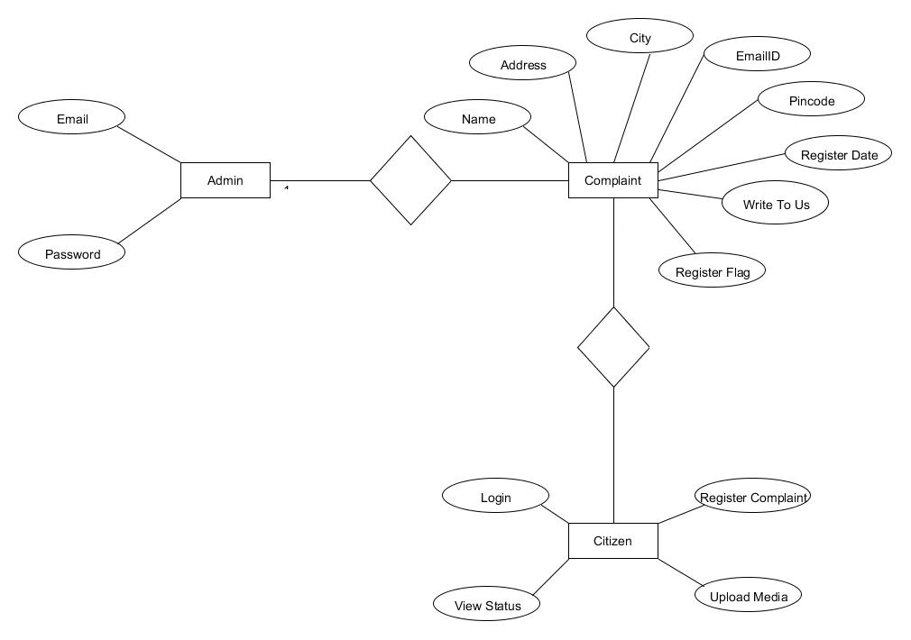

# Normalized Database Design & Data Dictionary

|  |  |  |  |  |  |
| --- | --- | --- | --- | --- | --- |
| **Table: Register_complaint** | | | | | |
| **Field Name** | **Data Type** | **Field Length** | **Key** | **Constraints** | **Extra** |
| name | int | 50 | Primary | NOT NULL | - |
| address | varchar | 100 | - | NOT NULL | - |
| city | varchar | 30 | - | NOT NULL | - |
| emailid | varchar | 30 | - | NOT NULL | - |
| register_date | date |  | - | NOT NULL | - |
| pincode | int |  | - | NOT NULL | - |
| write_to_us | varchar | 200 | - | NOT NULL | - |
| register_flag |  | 20 | - | NOT NULL | - |

|  |  |  |  |  |  |
| --- | --- | --- | --- | --- | --- |
| **Table: Login** | | | | | |
| **Field Name** | **Data Type** | **Field Length** | **Key** | **Constraints** | **Extra** |
| fullname | varchar | 50 | - | NOT NULL | - |
| email | varchar | 40 | - | NOT NULL | - |
| newpassword | varchar | 40 | - | NOT NULL | - |
| confirm_password | varchar | 40 | - | NOT NULL | - |

# Use Case Diagram

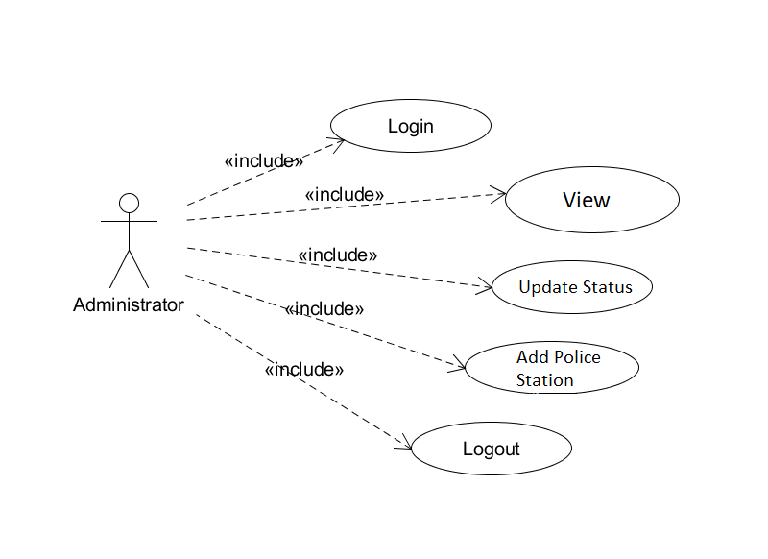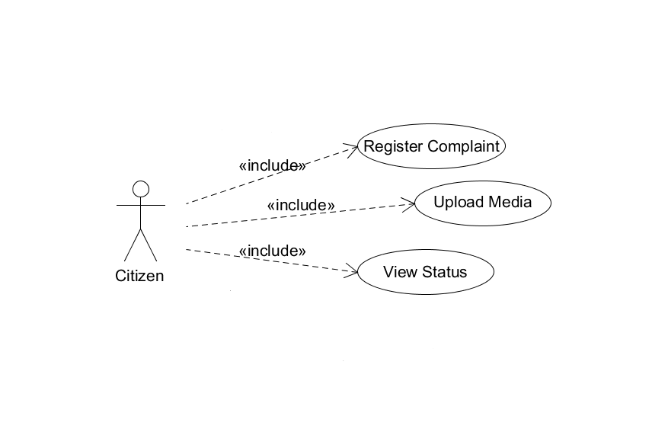

# Component Diagram

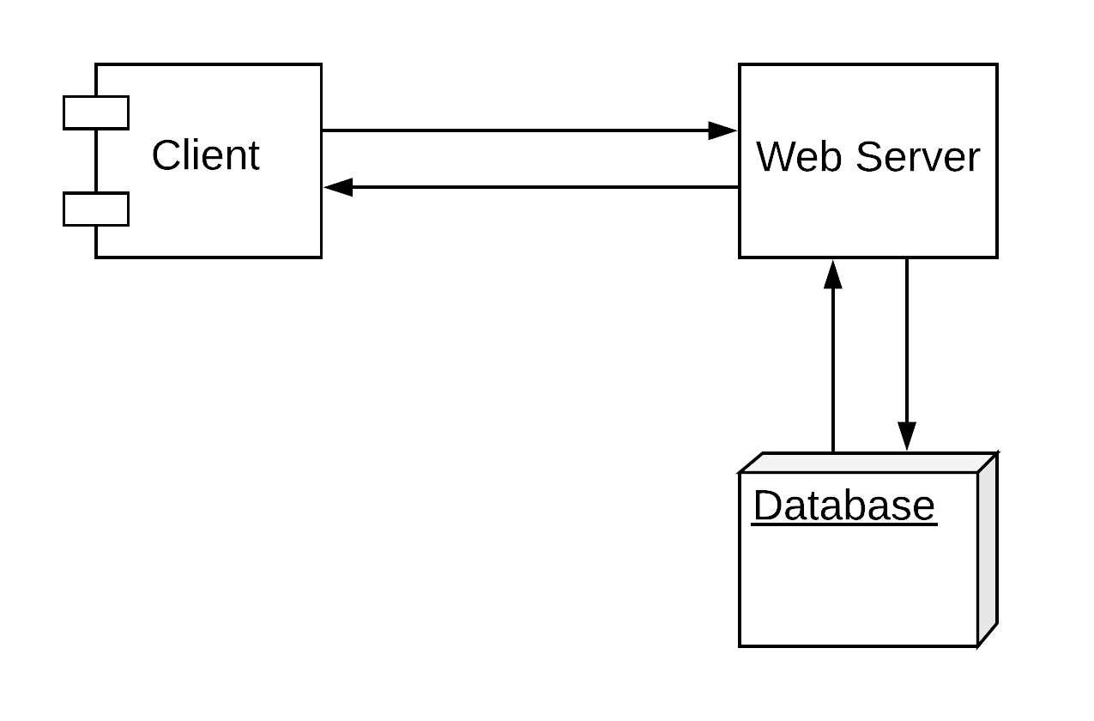

# Deployment Diagram

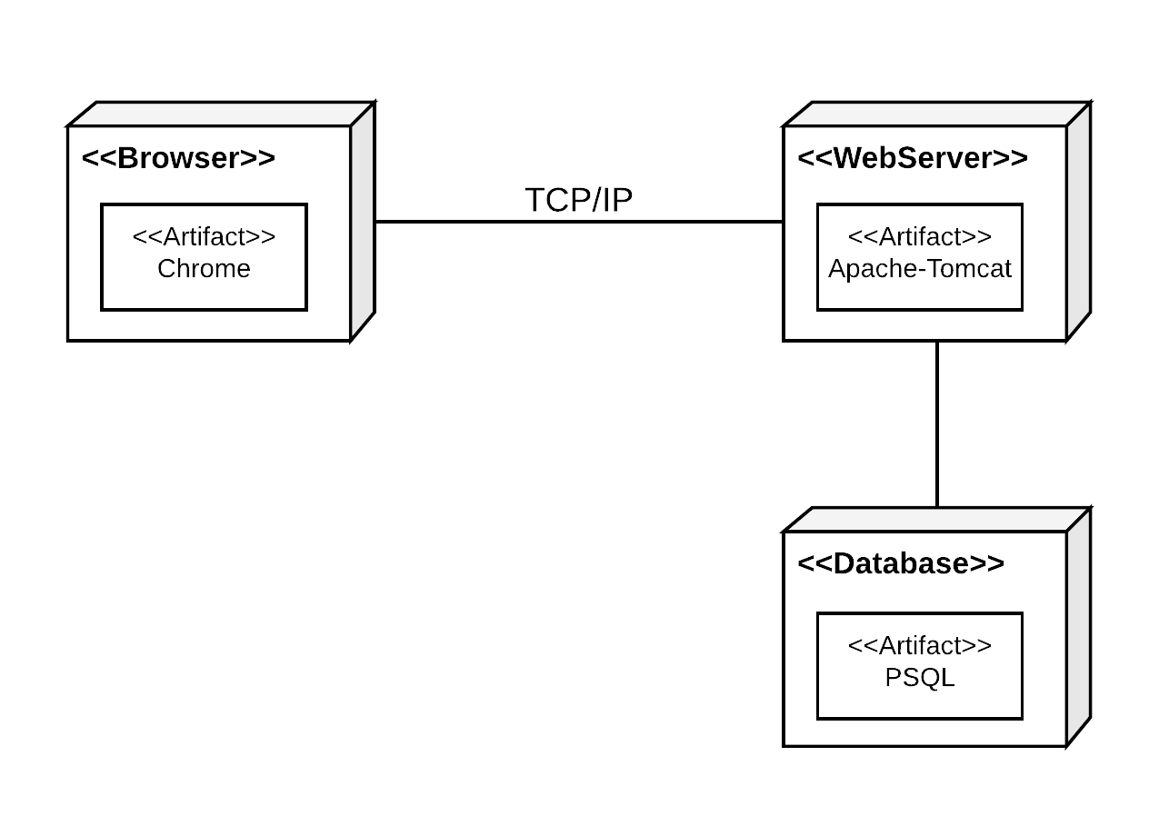

# 

**ActivityDiagram**

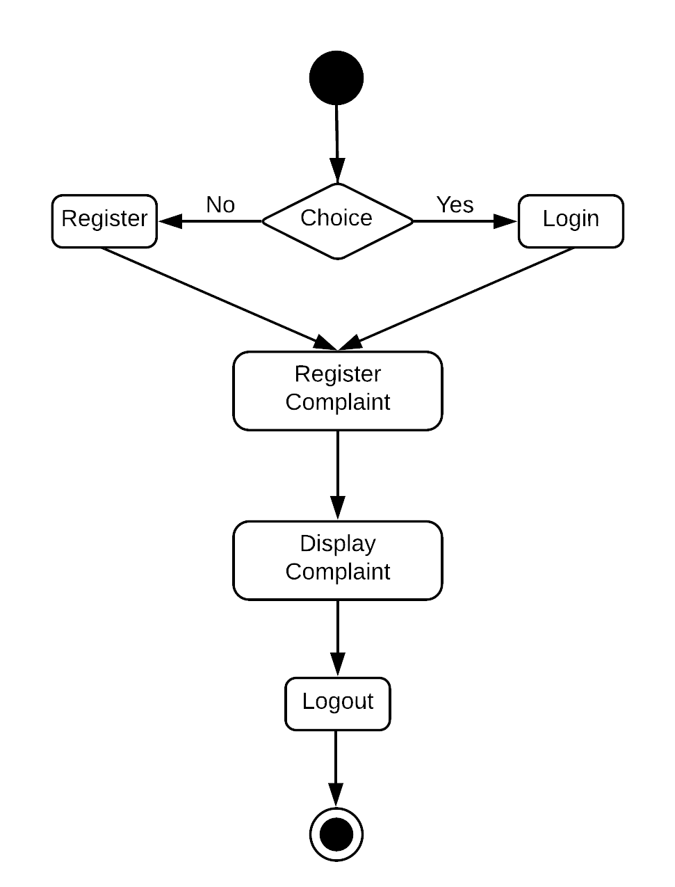

# Sequence Diagram

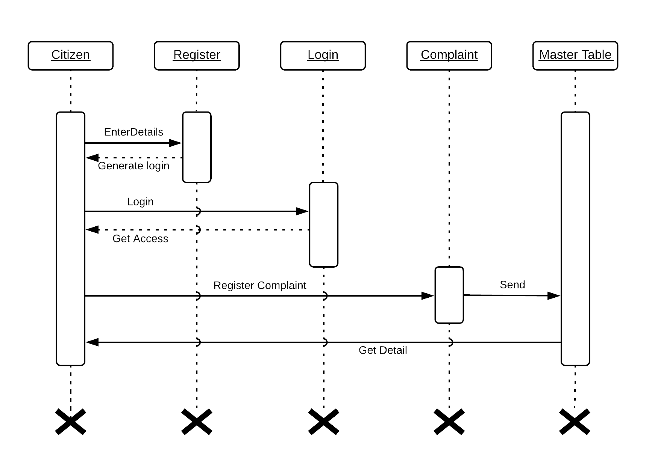

# Class Diagram

# G:\Code-Art-Solutions\Projects\documentation\Project-Docs\Pollution control\Class login.png

# State Chart Diagram

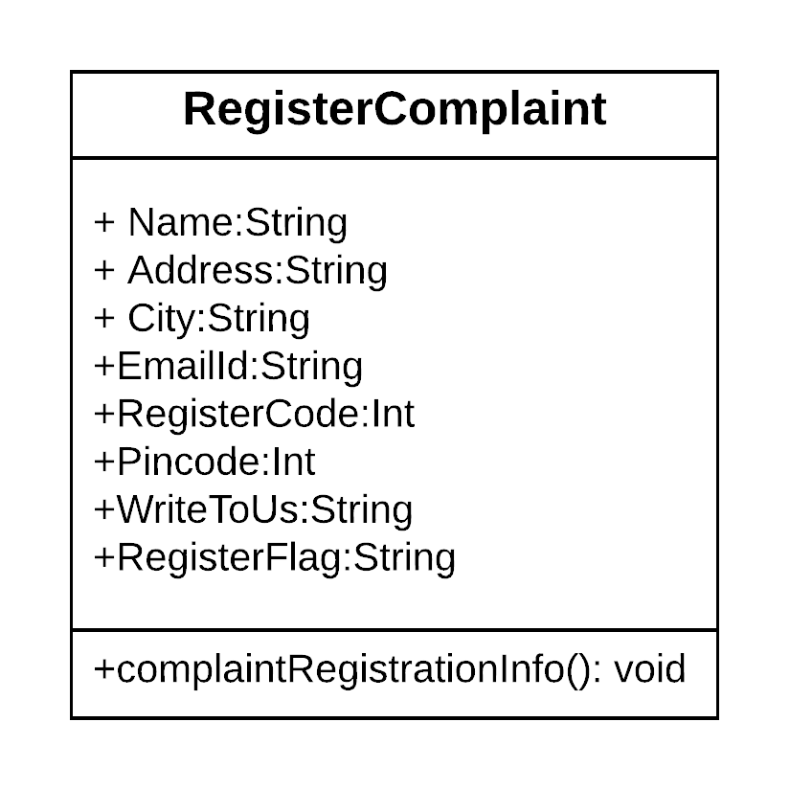

# Input & Output Screen’s

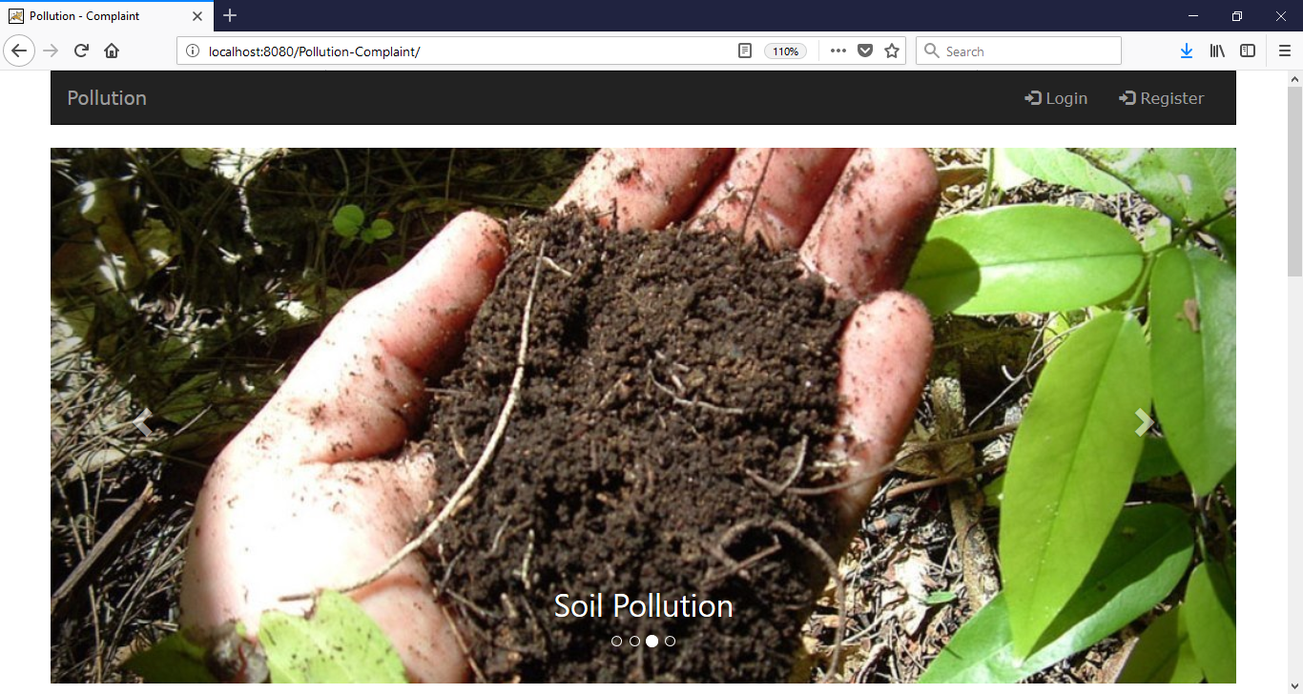

**Home Screen**

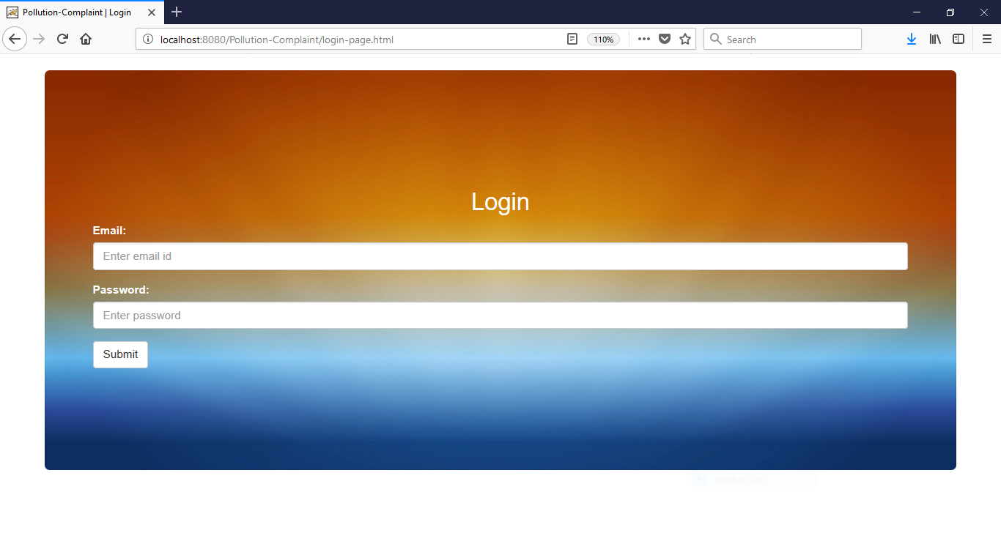

**Login Screen**

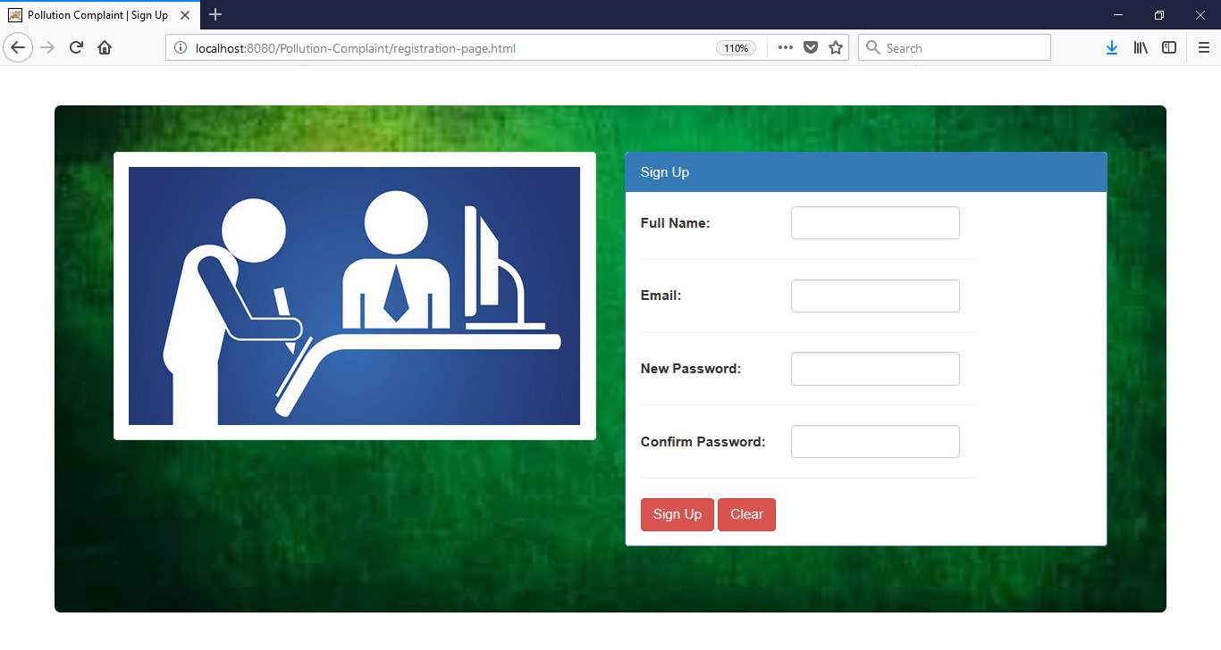

**Sign-Up Screen**

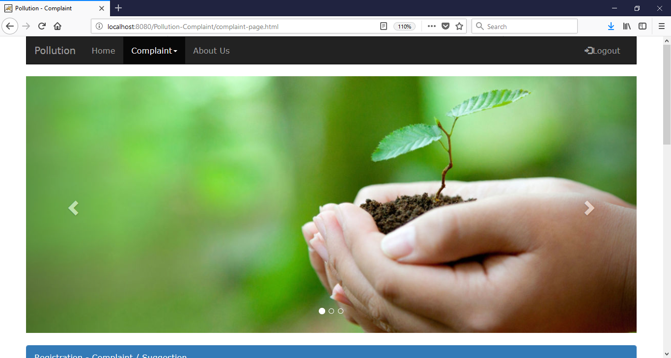

**After Login Screen**

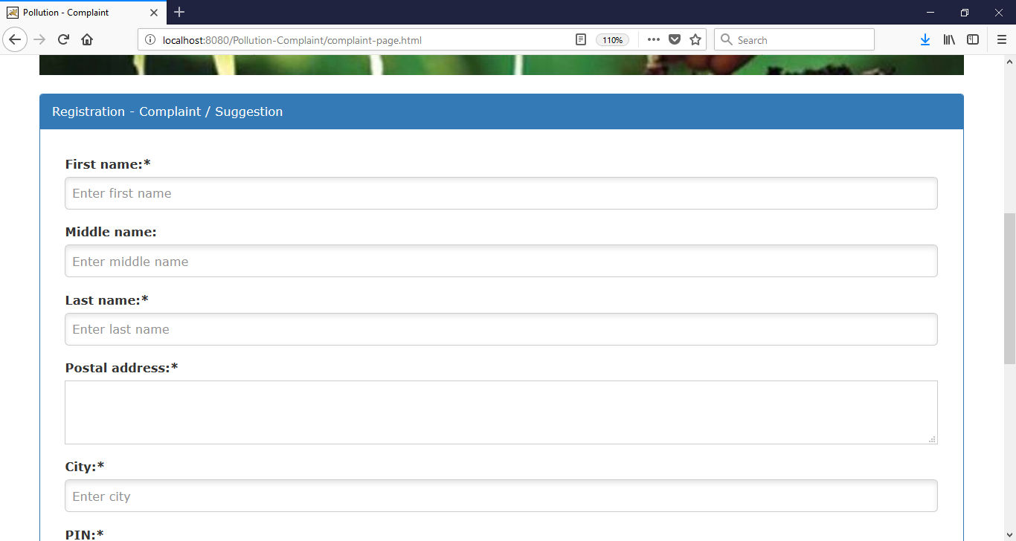

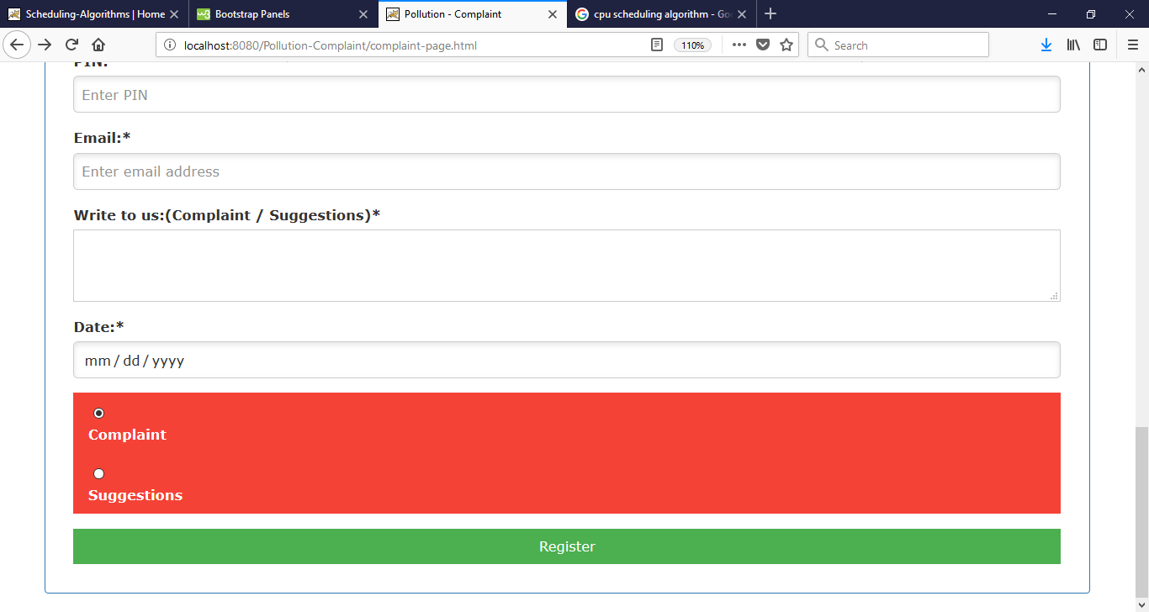

**Register Complaint**

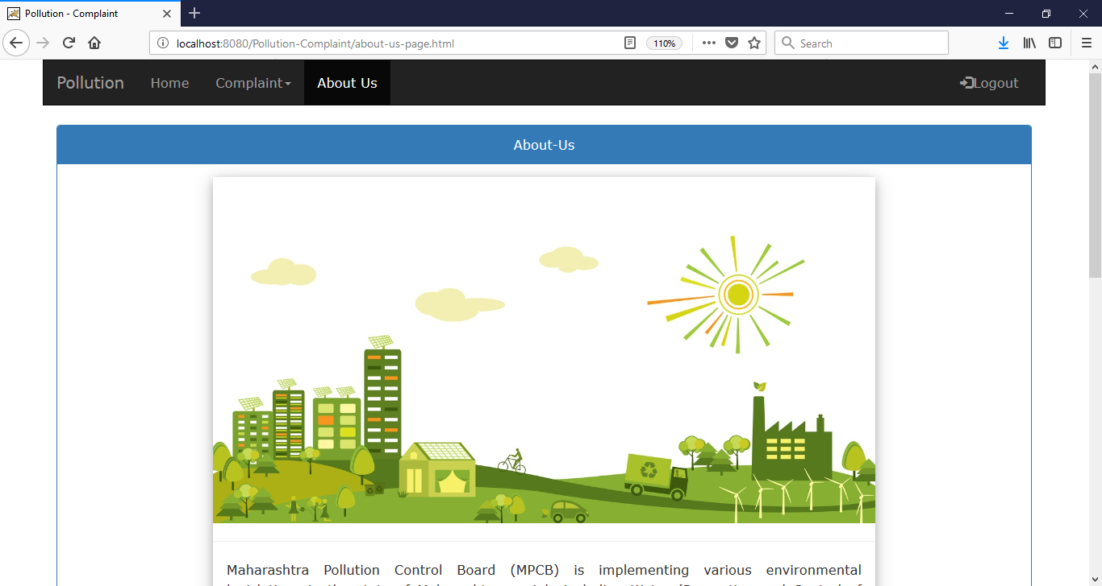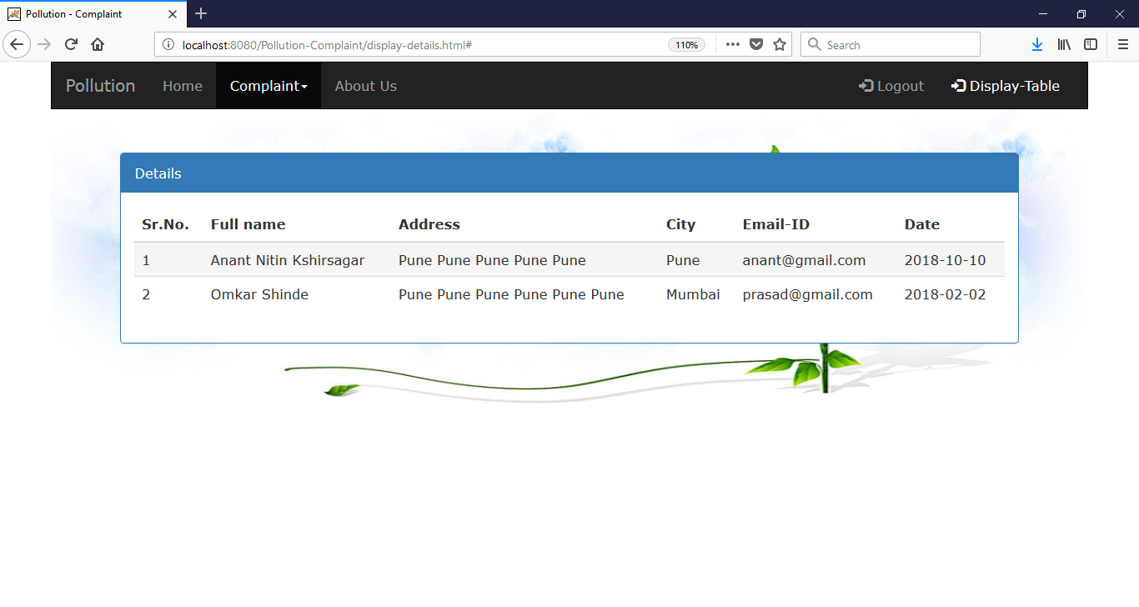

**Customer Detail Screen**

**Abou us**

**Bibliography**

**References links**

1. <https://www.w3schools.com/css/>
2. <https://www.w3schools.com/bootstrap4/default.asp>
3. <https://www.tutorialspoint.com/jsp/index.htm>
4. <https://www.javatpoint.com/jsp-useBean-action>
5. <https://www.w3schools.com/css/css_border.asp>